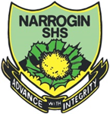
Year 11 ATAR CHEMISTRY Name:
Task No: | 5
Task Type: | Test
Content: | Atoms and elements
Task Description: | Complete the attached questions on the multiple choice answer sheet or in the spaces provided.  Marks will be awarded for presentation and working.  Test conditions (50 minutes).  Formulae and data booklet provided.  Non-programmable calculator permitted.
Total Marks: | 22
Weighting: | 2.15%
Due Date:

IMPORTANT NOTE TO CANDIDATES
No other items may be taken into the examination room. It is your responsibility to ensure that you do not have any unauthorised notes or other items of a non-personal nature in the examination room. If you have any unauthorised material with you, hand it to the supervisor before reading any further.

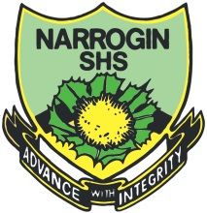
Multiple Choice Answer Sheet
Task Number: __ Name: _______________ Year: __

Multiple Choice – 12 questions.
Circle your choice. If you change your mind, cross out your choice out and circle the one you want. If it is messy, clearly write your choice next to question.

1. A B C D
2. A B C D
3. A B C D
4. A B C D
5. A B C D
6. A B C D
7. A B C D
8. A B C D
9. A B C D
10. A B C D
11. A B C D
12. A B C D

Section 1: Multiple Choice
Indicate your answers on the multiple choice answer sheet

- Which of the hydrocarbons listed below has the same general formula of C_{n}H_{2n}?

- pentene, benzene and hexene
- cycloheptane, butene and ethane
- cyclohexene, hexane and pentene
- cyclobutane, pentene and cyclopentane

- What is the correct IUPAC name for the compound CH₃(CH₂)₂CH(CH₃)CH₂Cl ?

- 1-chloroethylbutane
- 3-methyl-5-chloropentane
- 1-chloro-2-methylpentane
- 2-chloro-3-ethylbutane

- Which of the following has not been named correctly?

- 3-ethylpentane
- 2-ethylbutane
- 2,2-dimethylbutane
- 2,3-dimethylbutane

- The formula of ditmethylpropane may be written as

- (CH₃)₂CHCH₂CH₃
- CH₃CH(CH₃)₂
- (CH₃)₃CCH₃
- (CH₃)₂CHCH2CH(CH₃)₂

- Consider the reaction below:

CH₃CH₂CH₃ (g) + I₂ (g) ^{UV light} ?

- An addition reaction would occur.
- Iodopropane would be formed initially.
- Hydrogen iodide would be formed initially.
- Diiodopropane would be formed initially.
- A substitution reaction would occur.

Which of the following are correct for this reaction?

- (ii), (iii) and (v) only
- (i), (ii), (iii) and (v) only
- (i), (iv) and (v) only
- (iv) and (v) only

- Which of the following pairs are isomers?

- heptane and 3-ethylhexane
- but-1-ene and methylpropane
- 2,2,3-tribromobutane and 1,1,2-tribromoprop-1-ene
- 1,2-dimethylcyclohexane and oct-1-ene

- The correct IUPAC name of the substance, which is incorrectly names as 1-bromo-2,2-dimethylethane is

- 2,2-dimethyl-1-bromoethane
- 1-bromo-2-bromopropane
- 2-methyl-3-bromopropane
- 1,1-dimethyl-2-bromoethane

- The reaction between chlorine and methane in ultraviolet light is an example of

- an elimination reaction
- a substitution reaction
- an addition reaction
- a condensation reaction

- The product formed when ethene reacts with bromine at room temperature is likely to be

- CH₃CH₂Br
- CH₂CHBr
- CH₂BrCH₂Br
- CH₃CHBr₂

- What reactants could be used to produce 2-chlorobutane?

- Cl₂ and cyclobutene
- Cl₂ and CH₂CHCH₂CH₃
- Cl₂ and CH₃CH₂CH₂CH₃
- Cl₂ and C₄H₆

- Study the structural formulae and statements below. Which statement is incorrect?
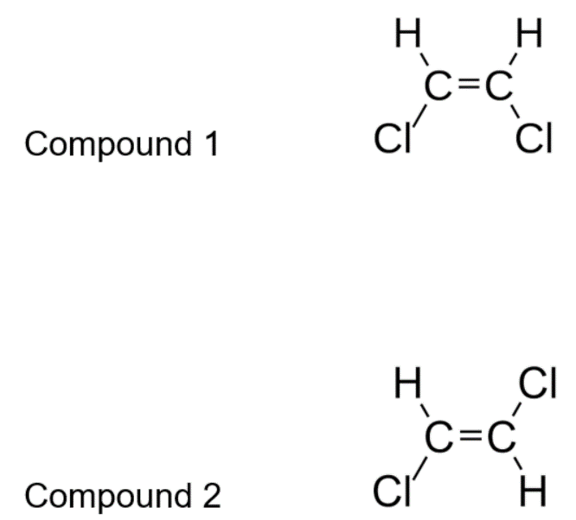

- (1) is cis-1,2-dichloroethene and (2) is trans-1,2-dichloroethene.
- Compounds (1) and (2) are geometric isomers.
- (1) is trans-1,2-dichloroethene and (2) is cis-1,2-dichloroethene.
- These compounds will have different melting and boiling points.

- Which compound, when reacted with chlorine, Cl₂, in the presence of UV light, would produce chlorocyclohexane?

- benzene
- cyclohexane
- cyclohexene
- hexane

Section 2: Short Answer
Write your answer in the spaces provided

- Draw the structural formula for (3 marks)

- tetrafluoromethane
- 1,5-dichloropent-2-ene
- 1-propylbenzene

- Name the following compounds using the IUPAC system (3 marks)

- CH₂ = CH - CH₂ – CH₃

CH₃
|
- CH₃ - CH₂ – CH - CH - CH₃
|
CH₃

- H
|
CH₃ – C = C – CH₃
|
H

- Write balanced equations for the following reactions and indicate the type of reaction.
(4 marks)

- Pent-2-ene is mixed with chlorine gas in the presence of UV light

- Hexane is combusted in excess oxygen

END OF TEST

